Supplementary material for

**Climate change and marine food webs: navigating structural uncertainty using qualitative network analysis with insights for salmon survival**

by L.G. Crozier, D. G. E. Gomes and D. D. Huff

Submitted to Global Change Biology

Contents

Table S1 Table of nodes 1

Table S2 Explanation of links 4

Table S3 Links that represent direct responses to climate warming in each temperature hypothesis 7

Table S4 Stability indices for the base model across temperature hypotheses 8

Table S5 Impact of climate press on all groups 9

Table S6 Sensitivity analysis of additional links that represent direct responses to climate warming in each node, one at a time 10

Supplement 1 Description of alternative food webs 12

Supplement 2 Outcomes from climate perturbation H1 evaluated across the entire network 13

Figure S2.1 Outcomes of climate press on base and mammal networks for all nodes 14

Supplement 3 Boosted regression tree results 15

Figure S3.1 Boosted regression tree influence plots for fall-run adult salmon outcomes 15

Literature cited 16

# Table S1 Table of nodes

Nodes in the conceptual model. The first column provides general categories of nodes that correspond with the colors in Figure 1. Additional columns show node reference name, describe the driver, salmon index, or functional group referred to, and provide an example of an index that could be used to represent the node.

|  |  |  |  |
| --- | --- | --- | --- |
|  |  |  |  |
|  |  |  |  |
| **Category** | **Node name** | **Description of node** | **Example indices or taxa** |
|  |  |  |  |
|  |  |  |  |
| Climate drivers | a1.Clim1 | Any climate driver that affects spring prey resources for salmon. | Sea surface temperature  (e.g., SSTarc, PDO) |
|  | a3.Clim2 | Any climate driver that affects summer or fall prey resources and is not correlated with a1.Clim1. | NPGO, upwelling |
|  |  |  |  |
| Salmon prey | b1.Prey.yr | Juvenile fish prey preferred by larger spring migrants, especially yearlings. | Winter ichthyoplankton index (January to March), which generally represents recruitment from winter-spawning fish. These larval fish are typically the size of prey for yearling salmon smolts in the spring. |
|  | b2.Prey.sub | Zooplankton and invertebrate prey preferred by smaller spring migrants, especially subyearlings. | Zooplankton index in spring, which generally represents non-fish prey that predominate in subyearling salmon diets during spring. |
|  | b3.Prey.Sep | Prey preferred by summer and fall migrants. | Abundance of juvenile anchovy. |
|  |  |  |  |
| Competitors | c1.Comp.altprey | Fish similar in size and location to juvenile salmon which are preferred by or satiating for predators, thereby reducing predation on salmon. | Abundance of adult anchovy, smelts, herring, sardine, or other forage fish. |
|  | c2.Comp.jelly | Consumers of lower trophic levels affecting salmon prey, but c2 do not contribute substantially to higher trophic levels. | Abundance of gelatinous species, such as pyrosomes and jellyfish, Chrysaora (Sea nettles). |
|  | c3.Comp | Consumers of lower trophic levels affecting salmon prey, but c3 do contribute substantially to higher trophic levels. | Abundance of Pacific whiting (hake). |
|  |  |  |  |

Table S1 Continued.

|  |  |  |  |
| --- | --- | --- | --- |
|  |  |  |  |
|  |  |  |  |
| **Category** | **Node name** | **Description of node** | **Example indices or taxa** |
|  |  |  |  |
|  |  |  |  |
| Predators | d1.Pred.sm | Predators that do not eat salmon adults or the largest smolts. Salmon smolts can outgrow predation that is limited by gape size, foraging range, or capture ability. | Abundance of murres amd shearwaters in the NCC. |
|  | d2.Pred.lg | Predators that prefer larger salmon juveniles. These predators also eat adult salmon. | Abundance of seals, California and Stellar sea lions |
|  | d3.Pred | Predators that consume salmon without any net effect on the size distribution of smolts. They could target a wide size range by including both small-preferring and large-preferring individuals. | Abundance of most piscivorous fish, e.g., jack mackerel, lingcod, dogfish. |
|  | d4.Pred.adult | Predators that specialize in subadult or adult salmon. | Abundance of Southern Resident killer whales. |
|  |  |  |  |
| Salmon condition | e1.Ch.cond.yr | Mean condition of spring yearling salmon smolts, reflecting any aspect of health that leads to higher survival. This node accounts for the general phenomenon that smaller animals tend to have lower survival rates. | Length or Fulton's condition index from May or June surveys for spring yearling smolts. |
|  | e2.Ch.cond.sub | Mean condition of early-migrating subyearling salmon smolts, reflecting any aspect of health that leads to higher survival. This node accounts for the general phenomenon that smaller animals tend to have lower survival rates. | Length or Fulton's condition index from May or June surveys for spring subyearling smolts. |
|  | e3.Ch.cond.Sep | Mean condition of late-migrating salmon smolts, reflecting any aspect of health that leads to higher survival. This node accounts for the general phenomenon that smaller animals tend to have lower survival rates. | Length or Fulton's condition index from September surveys for late-migrating salmon smolts. |

Table S1 Continued.

|  |  |  |  |
| --- | --- | --- | --- |
|  |  |  |  |
|  |  |  |  |
| **Category** | **Node name** | **Description of node** | **Example indices or taxa** |
|  |  |  |  |
|  |  |  |  |
| Juvenile salmon abundance | f1.Ch.juv.yr | Abundance of yearling smolts that survive their initial period of ocean entry (~4 weeks). | Catch per unit effort (CPUE) for yearlings from May or June JSOES surveys. |
|  | f2.Ch.juv.sub | Abundance of early subyearling smolts that survive their initial period of ocean entry (until late June). | CPUE for subyearling smolts from May or June JSOES surveys. |
|  | f3.Ch.juv.Sep | Abundance of late subyearling smolts, i.e., summer- and fall-migrating smolts that survive their initial period of ocean entry (until September). | CPUE for late-migrating subyearling smolts from September JSOES surveys. |
|  |  |  |  |
| Adult salmon | g1.SprCh.adult | Abundance of jack and adult returning spring-run Chinook salmon in the NCC. Note that we do not have a node for subadult spring Chinook because we assume that they are affected by prey resources and predators outside the NCC. | Counts of jack and adult spring-run Chinook salmon at a river mouth, Bonneville Dam, or spawning grounds adjusted for in-river harvest. |
|  | g3.FallCh.adult | Abundance of subadult and adult fall-run Chinook salmon in the NCC prior to harvest, or including harvested fish in this node. This node accounts for various age groups residing in or transiting through the NCC. | Counts of jack and adult fall-run Chinook returns adjusted for harvest. |
|  |  |  |  |
| Drivers outside the California Current ecosystem | non.NCC.spr | Net effects of factors outside of the NCC primarily affecting spring Chinook subadults, i.e., prey, competitors, predators, and fishing in Alaskan or international waters. Because Columbia River spring Chinook are rarely intercepted in Alaskan fisheries, these factors differ from those affecting fall-run Chinook salmon. | No index at this time. |
|  | non.NCC.fall | Net effects of factors outside of the NCC primarily affecting fall Chinook subadults, i.e., prey, competitors, predators, and fishing in Alaskan or international waters. Columbia River fall Chinook are often caught in Alaskan fisheries. | No index at this time. |
|  |  |  |  |

# Table S2 Explanation of links

The first column shows the two nodes that are connected by a positive (->) or negative (-*) link. The second column explains the rationale for including that link.

|  |  |  |  |  |
| --- | --- | --- | --- | --- |
|  |  | |  |  |
|  |  | |  |  |
| **Link** | | **Explanation** | | |  |
|  |  | |  |  |
|  |  | |  |  |
| a1.Clim1 -* b1.Prey.yr | | A negative link between climate forcing and some salmon prey reflects the negative correlation observed between certain preferred prey (e.g., sandlance) and warm-ocean years. | | |  |
| a1.Clim1 -* b2.Prey.sub | | A negative link between climate forcing and some salmon prey reflects the negative correlation observed between certain preferred prey (e.g., krill) or zooplankton (northern copepods) and warm-ocean years. | | |  |
| a3.Clim2 -> b3.Prey.Sep | | A positive link between the second climate driver and September prey reflects a the positive correlation between salmon diets in September surveys and the timing of anchovy biomass blooms. These blooms are not correlated with SST, but are likely influenced by other climate drivers. | | |  |
|  | |  | | |  |
|  |  | |  |  |
| b1.Prey.yr *-> c3.Comp | | Salmon diet overlaps with that of many other species. Some species, such as hake, are presumably abundant enough to depress prey population sizes locally. | | |  |
| b1.Prey.yr *-> d3.Pred | | We assume these fish species are abundant enough depress prey population sizes locally. | | |  |
| b1.Prey.yr -> e1.Ch.cond.yr | | We assume that more prey inherently leads to better salmon condition, although population means can be confounded by differences in survival (Daly and Brodeur, 2015). | | |  |
| b2.Prey.sub *-> c1.Comp.altprey | | Many forage fish are similar in size and diet to salmon smolts in spring, and hence are modeled as competitors with a negative impact on b2.prey.sub. | | |  |
| b2.Prey.sub *-> c2.Comp.jelly | | Gelatinous planktivores can be abundant enough to depress salmon prey (Ruzicka et al 2016), but are thought to provide little nutrition to higher trophic levels. Therefore, we model them as having a negative impact on b1, b2 and b3 prey nodes, with no positive impact on predators and no direct impact on salmon. | | |  |
| b2.Prey.sub *-> c3.Comp | | We assume some fish species are abundant enough depress prey population sizes locally. | | |  |
| b2.Prey.sub -> b1.Prey.yr | | Larval fish grow from zooplankton to juvenile fish. Juvenile fish also eat zooplankton prey, but we assume they are not abundant enough to depress prey populations. | | |  |
| b2.Prey.sub -> b3.Prey.Sep | | Spring zooplankton may grow directly into summer zooplankton prey (Brodeur et al 2011), and also provide food for juvenile forage fish that contribute to fall prey for salmon (Litz et al 2019). | | |  |
|  |  | |  |  |

Table S2 Continued

|  |  |  |  |  |  |
| --- | --- | --- | --- | --- | --- |
|  |  | |  |  | |
|  |  | |  |  | |
| **Link** | | **Explanation** | | |  | |
|  |  | |  |  | |
|  |  | |  |  | |
| c1.Comp.altprey *-> d1.Pred.sm | | Many predator groups consume forage fish. | | |  | |
| c1.Comp.altprey *-> d2.Pred.lg | | Many predator groups consume forage fish. | | |  | |
| c1.Comp.altprey *-> d3.Pred | | Many predator groups consume forage fish. | | |  | |
| c1.Comp.altprey -> b3.Prey.Sep | | Winter- and spring-spawning forage fish provide young-of-the-year fish to support juvenile salmon in summer. | | |  | |
| c1.Comp.altprey -> f1.Ch.juv.yr | | The alternative prey hypothesis implies that fewer salmon are consumed when alternative prey are abundant, resulting in a benefit to salmon. | | |  | |
| c1.Comp.altprey -> f2.Ch.juv.sub | | The alternative prey hypothesis implies that fewer salmon are consumed when alternative prey are abundant, resulting in a benefit to salmon. | | |  | |
| c3.Comp -* f3.Ch.juv.Sep | | The alternative prey hypothesis implies that fewer salmon are consumed when alternative prey are abundant, resulting in a benefit to salmon. | | |  | |
| c3.Comp *-> d2.Pred.lg | | Many predator groups consume hake. | | |  | |
| c3.Comp *-> d3.Pred | | Many predator groups consume hake. | | |  | |
|  |  | |  |  | |
| d1.Pred.sm -* f1.Ch.juv.yr | | Direct consumption reduces the prey— salmon— but because salmon make up a relatively small proportion of the predator’s diet, we did not apply a quantitative benefit to the predator. | | |  | |
| d1.Pred.sm -* f2.Ch.juv.sub | | Direct consumption reduces the prey— salmon— but because salmon make up a relatively small proportion of the predator’s diet, we did not apply a quantitative benefit to the predator. | | |  | |
| d1.Pred.sm -* f3.Ch.juv.Sep | | Direct consumption reduces the prey— salmon— but because salmon make up a relatively small proportion of the predator’s diet, we did not apply a quantitative benefit to the predator. | | |  | |
| d2.Pred.lg -* f1.Ch.juv.yr | | Direct consumption reduces the prey— salmon— but because salmon make up a relatively small proportion of the predator’s diet, we did not apply a quantitative benefit to the predator. | | |  | |
| d2.Pred.lg -* f2.Ch.juv.sub | | Direct consumption reduces the prey— salmon— but because smolts make up a relatively small proportion of the predator’s diet, we did not apply a quantitative benefit to the predator. | | |  | |
| d2.Pred.lg -* f3.Ch.juv.Sep | | Direct consumption reduces the prey— salmon— but because smolts make up a relatively small proportion of the predator’s diet, we did not apply a quantitative benefit to the predator. | | |  | |
| d3.Pred -* f1.Ch.juv.yr | | Direct consumption reduces the prey— salmon— but because smolts make up a relatively small proportion of the predator’s diet, we did not apply a quantitative benefit to the predator. | | |  | |

Table S2 Continued

|  |  |  |  |  |  |  |  |  |
| --- | --- | --- | --- | --- | --- | --- | --- | --- |
|  | |  | | | | | |  |
|  |  | | | |  |  |
|  |  | | | |  |  |
|  |  | | | |  |  |
| **Link** | | | **Explanation** | | | | |  |
|  |  | | | |  |  |
|  |  | | | |  |  |
| d3.Pred -* f2.Ch.juv.sub | | | Direct consumption reduces the prey— salmon— but because salmon make up a relatively small proportion of the predator’s diet, we did not apply a quantitative benefit to the predator. | | | | |  |
|  |  | | | |  |  |
| e1.Ch.cond.yr -> f1.Ch.juv.yr | | | | We assume that better condition leads to higher survival, all else being equal. | | | |  |
| e2.Ch.cond.sub -> f2.Ch.juv.sub | | | | We assume that better condition leads to higher survival, all else being equal. | | | |  |
| e3.Ch.cond.Sep -> f3.Ch.juv.Sep | | | | We assume that better condition leads to higher survival, all else being equal. | | | |  |
| f1.Ch.juv.yr -> g1.SprCh.adult | | | | We assume that more juvenile salmon lead to more adult salmon. We assume that all interior spring-run Chinook salmon follow the spring yearling life history pattern, f1. | | | |  |
| f1.Ch.juv.yr -> g3.FallCh.adult | | | | We assume that more juvenile salmon lead to more adult salmon. Adult fall-run Chinook stem from all three juvenile salmon nodes, f1, f2 & f3. | | | |  |
| f2.Ch.juv.sub -> g3.FallCh.adult | | | | We assume that more juvenile salmon lead to more adult salmon. Adult fall-run Chinook stem from all three juvenile salmon nodes, f1, f2 & f3. | | | |  |
| f3.Ch.juv.Sep -> g3.FallCh.adult | | | | We assume that more juvenile salmon lead to more adult salmon. Adult fall-run Chinook stem from all three juvenile salmon nodes, f1, f2 & f3. | | | |  |
| g1.SprCh.adult *-> d2.Pred.lg | | | | We assume that predators on adult Chinook benefit from this predation and have a negative impact on salmon. | | | |  |
| g1.SprCh.adult *-> d4.Pred.adult | | | | We assume that predators on adult Chinook benefit from this predation and have a negative impact on salmon. | | | |  |
| g3.FallCh.adult *-> d2.Pred.lg | | | | We assume that predators on adult Chinook benefit from this predation and have a negative impact on salmon. | | | |  |
| g3.FallCh.adult *-> d4.Pred.adult | | | | We assume that predators on adult Chinook benefit from this predation and have a negative impact on salmon. | | | |  |
|  |  | | | |  |  |
| non.NCC.fall -> g1.SprCh.adult | | | |  | | --- | | Dynamics occurring in between the smolt and adult stages are important but do not necessarily interact with other nodes in this network. Many of them occur in Canadian or Alaskan waters. We represent them with a single node each for spring and fall Chinook, reflecting their different migration routes and residence times in the NCC | | | | | | |  |
| non.NCC.spr -> g3.FallCh.adult | | | |  | | --- | | Dynamics occuring in between the smolt and adult stages are important but do not necessarily interact with other nodes in this network. Many of them occur in Canadian or Alaskan waters. We represent them with a single node each for spring and fall Chinook, reflecting their different migration routes and residence times in the NCC | | | | | | |  |
|  | |  | | | | | |  |
|  | |  | | | | | |  |  |  |

# Table S3 Links that represent direct responses to climate warming in each temperature hypothesis

|  |  |  |  |
| --- | --- | --- | --- |

|  |  |  |
| --- | --- | --- |
| **Temperature Hypothesis** | **Functional group targeted** | **Links Added** |

|  |  |  |  |
| --- | --- | --- | --- |

|  |  |  |
| --- | --- | --- |
| H1 | Prey | a1.Clim1 -* b1.Prey.yr |
|  |  | a1.Clim1 -* b2.Prey.sub |

|  |  |  |  |
| --- | --- | --- | --- |

|  |  |  |
| --- | --- | --- |
| H2 | Condition | a1.Clim1 -* b1.Prey.yr |
|  |  | a1.Clim1 -* b2.Prey.sub |
|  |  | a1.Clim1 -* e1.Ch.cond.yr |
|  |  | a1.Clim1 -* e2.Ch.cond.sub |
|  |  | a1.Clim1 -* e3.Ch.cond.Sep |

|  |  |  |  |
| --- | --- | --- | --- |

|  |  |  |
| --- | --- | --- |
| H3 | Competitors | a1.Clim1 -* b1.Prey.yr |
|  |  | a1.Clim1 -* b2.Prey.sub |
|  |  | a1.Clim1 -> c2.Comp.jelly |
|  |  | a1.Clim1 -> c3.Comp |
|  |  | a1.Clim1 -> c1.Comp.altprey |

|  |  |  |  |
| --- | --- | --- | --- |

|  |  |  |
| --- | --- | --- |
| H4 | Juvenile Predators | a1.Clim1 -* b1.Prey.yr |
|  | a1.Clim1 -* b2.Prey.sub |
|  |  | a1.Clim1 -> d1.Pred.sm |
|  |  | a1.Clim1 -> d2.Pred.lg |
|  |  | a1.Clim1 -> d3.Pred |

|  |  |  |  |
| --- | --- | --- | --- |

|  |  |  |
| --- | --- | --- |
| H5 | All Predators | a1.Clim1 -* b1.Prey.yr |
|  | a1.Clim1 -* b2.Prey.sub |
|  |  | a1.Clim1 -> d1.Pred.sm |
|  |  | a1.Clim1 -> d2.Pred.lg |
|  |  | a1.Clim1 -> d3.Pred |
|  |  | a1.Clim1 -> d4.Pred.adult |

|  |  |  |  |
| --- | --- | --- | --- |

|  |  |  |
| --- | --- | --- |
| H6 | All | a1.Clim1 -* b1.Prey.yr |
|  |  | a1.Clim1 -* b2.Prey.sub |
|  |  | a1.Clim1 -* e1.Ch.cond.yr |
|  |  | a1.Clim1 -* e2.Ch.cond.sub |
|  |  | a1.Clim1 -* e3.Ch.cond.Sep |
|  |  | a1.Clim1 -> c1.Comp.altprey |
|  |  | a1.Clim1 -> c2.Comp.jelly |
|  |  | a1.Clim1 -> c3.Comp |
|  |  | a1.Clim1 -> d1.Pred.sm |
|  |  | a1.Clim1 -> d2.Pred.lg |
|  |  | a1.Clim1 -> d3.Pred |
|  |  | a1.Clim1 -> d4.Pred.adult |
|  |  |  |

# Table S4 Stability indices for the base model across temperature hypotheses

Stability indices are shown for the base model across temperature hypotheses (model index) for the base model, followed by the alternative food webs (model description) for the H1 scenario. Modifications to the base network in the temperature hypotheses are pictured in Figure 2, while modifications to the base network in the alternative food webs are pictured in Figure 3. Columns display the target of the model modification, the total number of models simulated to attain 100,000 stable matrices, the percent acceptance rate, and press perturbation (where the first climate node received a positive press with no alteration of the second climate node). The mean outcome for spring- and fall-run Chinook salmon adults is also presented.

|  |  |  |  |
| --- | --- | --- | --- |

|  |  |  |  |  |  |  |  |
| --- | --- | --- | --- | --- | --- | --- | --- |
|  |  |  |  |  | |  |  |
| **Model Index** | **Model Description** | **No. Models** | **Acceptance (%)** | **Press** | **Spring Chinook Response** | | **Fall Chinook Response** |

|  |  |  |  |
| --- | --- | --- | --- |

|  |  |  |  |  |  |  |
| --- | --- | --- | --- | --- | --- | --- |
| H1 | Prey | 148734 | 67 | C10 | -0.29 | 0.41 |
| H2 | Condition | 149947 | 67 | C10 | 0.10 | -0.23 |
| H3 | Competitors | 149136 | 67 | C10 | 0.00 | -0.04 |
| H4 | Juvenile Predators | 148809 | 67 | C10 | -0.06 | -0.28 |
| H5 | All Predators | 149084 | 67 | C10 | -0.23 | -0.31 |
| H6 | All | 148767 | 67 | C10 | 0.13 | -0.60 |
|  |  |  |  |  |  |  |

|  |  |  |  |
| --- | --- | --- | --- |

|  |  |  |  |  |  |  |
| --- | --- | --- | --- | --- | --- | --- |
|  |  |  |  |  |  |  |
| H1 | Mammal | 10736 | 93 | C10 | 0.12 | 0.27 |
| H1 | Bird | 14236 | 70 | C10 | -0.3 | 0.45 |
| H1 | Base | 14752 | 68 | C10 | -0.3 | 0.42 |
| H1 | Fish Predators 1 | 14889 | 67 | C10 | -0.43 | 0.5 |
| H1 | Alternative Prey | 14953 | 67 | C10 | -0.28 | 0.51 |
| H1 | Fish Predators 2 | 15072 | 66 | C10 | -0.47 | 0.4 |
|  |  |  |  |  |  |  |

# Table S5 Impact of climate press on all groups

Mean outcomes for all functional groups (Node) after a positive press on climate (a1.Clim1) for each temperature hypothesis (H1:H6).

|  |  |  |  |
| --- | --- | --- | --- |

|  |  |  |  |  |  |  |  |
| --- | --- | --- | --- | --- | --- | --- | --- |
|  |  |  |  |  |  |  |  |
| **Node** |  | **H1** | **H2** | **H3** | **H4** | **H5** | **H6** |

|  |  |  |  |
| --- | --- | --- | --- |

|  |  |  |  |  |  |  |  |
| --- | --- | --- | --- | --- | --- | --- | --- |
| a1.Clim1 |  | 1 | 1 | 1 | 1 | 1 | 1 |
| a3.Clim2 |  | 0 | 0 | 0 | 0 | 0 | 0 |

|  |  |  |  |
| --- | --- | --- | --- |

|  |  |  |  |  |  |  |  |
| --- | --- | --- | --- | --- | --- | --- | --- |
| b1.Prey.yr |  | -0.62 | -0.73 | -0.69 | -0.65 | -0.72 | -0.76 |
| b2.Prey.sub |  | -0.83 | -0.86 | -0.92 | -0.32 | -0.4 | -0.74 |
| b3.Prey.Sep |  | 0.32 | 0.31 | -0.23 | -0.03 | -0.01 | -0.29 |
| c1.Comp.altprey |  | 0.12 | 0.39 | 0.55 | -0.53 | -0.43 | 0.15 |
| c2.Comp.jelly |  | -0.57 | -0.61 | -0.13 | -0.33 | -0.39 | -0.13 |
| c3.Comp |  | -0.45 | -0.24 | -0.33 | -0.41 | -0.33 | -0.19 |
| d1.Pred.sm |  | 0.12 | 0.39 | 0.55 | 0.7 | 0.76 | 0.84 |
| d2.Pred.lg |  | 0.17 | -0.32 | 0.05 | -0.28 | -0.46 | -0.54 |
| d3.Pred |  | -0.9 | -0.76 | -0.73 | -0.28 | -0.27 | -0.24 |
| d4.Pred.adult |  | 0.23 | -0.28 | -0.1 | -0.47 | -0.07 | -0.38 |
| e1.Ch.cond.yr |  | -0.62 | -0.92 | -0.69 | -0.65 | -0.72 | -0.89 |
| e2.Ch.cond.sub |  | -0.83 | -0.96 | -0.92 | -0.32 | -0.4 | -0.91 |
| e3.Ch.cond.Sep |  | 0.32 | -0.61 | -0.23 | -0.03 | -0.01 | -0.7 |
| f1.Ch.juv.yr |  | 0.11 | -0.28 | -0.03 | -0.62 | -0.55 | -0.56 |
| f2.Ch.juv.sub |  | 0.02 | -0.26 | -0.18 | -0.41 | -0.32 | -0.46 |
| f3.Ch.juv.Sep |  | 0.66 | 0.09 | 0.19 | 0.1 | 0.15 | -0.27 |
| g1.SprCh.adult |  | -0.29 | 0.1 | 0 | -0.06 | -0.23 | 0.13 |
| g3.FallCh.adult |  | 0.41 | -0.23 | -0.04 | -0.28 | -0.31 | -0.6 |
|  |  |  |  |  |  |  |  |

# Table S6 Sensitivity analysis of additional links that represent direct responses to climate warming in each node, one at a time

Starting with the base model in Figure 1, we added a link from a1.Clim1 to the node in the Node column. In three cases, this did not change the model from the base model, because a1, b1 and b2 already were linked to climate. However, the models were different for the other nodes. We also tested both positive and negative signs for the new link. Responses are shown for both spring-run and fall-run Chinook salmon based on both the base network and the mammal network. We also extracted the sign of the link that was predicted to have the most detrimental impact – a negative impact on prey groups and directly on salmon nodes, and a positive impact on competitors and predators (shown in the “Worst Scenario Sign of Climate Impact” column), and copied the associated result for spring-run in the final column. Perturbations to the base network are shown first, followed by perturbations to the mammal network.

|  |  |  |  |
| --- | --- | --- | --- |

|  |  |  |  |  |  |  |  |  |  |  |  |  |  |  |  |  |  |  |  |  |
| --- | --- | --- | --- | --- | --- | --- | --- | --- | --- | --- | --- | --- | --- | --- | --- | --- | --- | --- | --- | --- |
| **Node** | |  | | **Positive Link Spring-run Response** | | | **Positive Link Fall-run Response** | | **Negative Link Spring-run Response** | | **Negative Link Fall-run Response** | | | | **Worst Scenario Sign of Climate Impact** | | **Worst Scenario Spring-run Response** | | | |
| **Base Network** | | | | | |  | | |  | | | |  |  | | | | |  |
| a1.Clim1 |  | | | -0.3 | | 0.42 | | | -0.29 | | | | 0.41 | neg | | | | | -0.29 |
| a3.Clim2 |  | | | -0.33 | | 0.41 | | | -0.09 | | | | 0.24 | neg | | | | | -0.09 |
| b1.Prey.yr | | |  | | -0.29 | | | 0.42 | | -0.29 | | 0.42 | | | | neg | | -0.29 | | |
| b2.Prey.sub | | |  | | -0.28 | | | 0.41 | | -0.29 | | 0.41 | | | | neg | | -0.29 | | |
| b3.Prey.Sep | | |  | | -0.33 | | | 0.41 | | -0.12 | | 0.27 | | | | neg | | -0.12 | | |
| c1.Comp.altprey | | |  | | -0.2 | | | 0.2 | | -0.28 | | 0.49 | | | | pos | | -0.2 | | |
| c2.Comp.jelly | | |  | | -0.09 | | | 0.32 | | -0.44 | | 0.37 | | | | pos | | -0.09 | | |
| c3.Comp | | |  | | -0.18 | | | 0.09 | | -0.29 | | 0.58 | | | | pos | | -0.18 | | |
| d1.Pred.sm | | |  | | 0.04 | | | -0.1 | | -0.39 | | 0.58 | | | | pos | | 0.04 | | |
| d2.Pred.lg | | |  | | -0.34 | | | 0.15 | | -0.18 | | 0.49 | | | | pos | | -0.34 | | |
| d3.Pred | | |  | | -0.32 | | | 0.42 | | -0.17 | | 0.27 | | | | pos | | -0.32 | | |
| d4.Pred.adult | | |  | | -0.44 | | | 0.29 | | 0.03 | | 0.41 | | | | pos | | -0.44 | | |
| e1.Ch.cond.yr | | |  | | -0.04 | | | 0.36 | | -0.44 | | 0.35 | | | | neg | | -0.44 | | |
| e2.Ch.cond.sub | | |  | | -0.56 | | | 0.67 | | 0.01 | | 0.07 | | | | neg | | 0.01 | | |
| e3.Ch.cond.Sep | | |  | | -0.49 | | | 0.6 | | 0.07 | | 0.02 | | | | neg | | 0.07 | | |
| f1.Ch.juv.yr | | |  | | -0.06 | | | 0.39 | | -0.45 | | 0.35 | | | | neg | | -0.45 | | |
| f2.Ch.juv.sub | | |  | | -0.52 | | | 0.62 | | 0.04 | | 0.04 | | | | neg | | 0.04 | | |
| f3.Ch.juv.Sep | | |  | | -0.47 | | | 0.56 | | 0.03 | | 0.06 | | | | neg | | 0.03 | | |
| g1.SprCh.adult | | |  | | 0.22 | | | 0.08 | | -0.62 | | 0.59 | | | | neg | | -0.62 | | |
| g3.FallCh.adult | | |  | | -0.48 | | | 0.6 | | 0.02 | | 0.05 | | | | neg | | 0.02 | | |
| non.NCC.spr | | |  | | -0.51 | | | 0.62 | | 0.08 | | -0.02 | | | | neg | | 0.08 | | |
| non.NCC.fall | | |  | | 0.24 | | | 0.03 | | -0.6 | | 0.58 | | | | neg | | -0.6 | | |
|  | | |  | |  | | |  | |  | |  | | | |  | |  | | |

Table S6 Continued

|  |  |  |  |  |  |
| --- | --- | --- | --- | --- | --- |
|  | |  | | |  |
|  |  | |  |  | |
|  |  | |  |  | |

|  |  |  |  |  |  |  |  |  |  |  |  |  |  |  |  |  |  |  |  |  |
| --- | --- | --- | --- | --- | --- | --- | --- | --- | --- | --- | --- | --- | --- | --- | --- | --- | --- | --- | --- | --- |
| **Node** | |  | | **Positive Link Spring-run Response** | | | **Positive Link Fall-run Response** | | **Negative Link Spring-run Response** | | **Negative Link Fall-run Response** | | | | **Worst Scenario Sign of Climate Impact** | | **Worst Scenario Spring-run Response** | | | |
| **Mammal Network** | | | | | |  | | |  | | | |  |  | | | | |  |
| a1.Clim1 |  | | | 0.12 | | 0.29 | | | 0.12 | | | | 0.28 | neg | | | | | 0.12 |
| a3.Clim2 |  | | | 0.02 | | 0.25 | | | 0.22 | | | | 0.2 | neg | | | | | 0.22 |
| b1.Prey.yr | | |  | | 0.11 | | | 0.29 | | 0.11 | | 0.26 | | | | neg | | 0.11 | | |
| b2.Prey.sub | | |  | | 0.13 | | | 0.28 | | 0.11 | | 0.28 | | | | neg | | 0.11 | | |
| b3.Prey.Sep | | |  | | 0.01 | | | 0.24 | | 0.2 | | 0.21 | | | | neg | | 0.2 | | |
| c1.Comp.altprey | | |  | | -0.13 | | | 0.02 | | 0.31 | | 0.43 | | | | pos | | -0.13 | | |
| c2.Comp.jelly | | |  | | 0.37 | | | 0.31 | | -0.24 | | 0.13 | | | | pos | | 0.37 | | |
| c3.Comp | | |  | | -0.25 | | | -0.12 | | 0.43 | | 0.53 | | | | pos | | -0.25 | | |
| d1.Pred.sm | | |  | | -0.19 | | | -0.26 | | 0.31 | | 0.53 | | | | pos | | -0.19 | | |
| d2.Pred.lg | | |  | | -0.35 | | | -0.06 | | 0.34 | | 0.38 | | | | pos | | -0.35 | | |
| d3.Pred | | |  | | 0.07 | | | 0.23 | | 0.13 | | 0.23 | | | | pos | | 0.07 | | |
| d4.Pred.adult | | |  | | -0.41 | | | -0.04 | | 0.48 | | 0.45 | | | | pos | | -0.41 | | |
| e1.Ch.cond.yr | | |  | | 0.57 | | | 0.54 | | -0.34 | | 0.01 | | | | neg | | -0.34 | | |
| e2.Ch.cond.sub | | |  | | 0.12 | | | 0.54 | | 0.12 | | 0.01 | | | | neg | | 0.12 | | |
| e3.Ch.cond.Sep | | |  | | 0.1 | | | 0.45 | | 0.11 | | -0.07 | | | | neg | | 0.11 | | |
| f1.Ch.juv.yr | | |  | | 0.46 | | | 0.44 | | -0.41 | | 0.01 | | | | neg | | -0.41 | | |
| f2.Ch.juv.sub | | |  | | 0.13 | | | 0.45 | | 0.11 | | -0.01 | | | | neg | | 0.11 | | |
| f3.Ch.juv.Sep | | |  | | 0.1 | | | 0.42 | | 0.12 | | 0.02 | | | | neg | | 0.12 | | |
| g1.SprCh.adult | | |  | | 0.47 | | | 0.29 | | -0.41 | | 0.28 | | | | neg | | -0.41 | | |
| g3.FallCh.adult | | |  | | 0.12 | | | 0.44 | | 0.12 | | 0.03 | | | | neg | | 0.12 | | |
| non.NCC.fall | | |  | | 0.12 | | | 0.45 | | 0.11 | | -0.04 | | | | neg | | 0.11 | | |
| non.NCC.spr | | |  | | 0.49 | | | 0.28 | | -0.43 | | 0.28 | | | | neg | | -0.43 | | |
|  | | |  | |  | | |  | |  | |  | | | |  | |  | | |

# Supplement 1 Description of alternative food webs

We developed an alternative food web to manipulate most of the nodes in the base model. Each modification had a “target,” referring to the node that motivated the modification. Below, we briefly describe the motivation and modifications made for each target.

1. **Alternative prey**: Forage fish play important and complex roles in the ecosystem. In our base model, we assumed that they conferred a net benefit to salmon by satiating predators or diverting predators away from salmon, increasing the abundance of salmon. However, it is also possible that there is no net benefit to salmon, because the increased consumption of forage fish could be counteracted by the attraction of more predators. To explore this hypothesis in the model, we removed the positive link from forage fish c1 to juvenile salmon (f1, f2 and f3). This experiment removes the role of forage fish as alternative prey. **Expected outcome**: more negative outcomes for salmon adults.
2. **Birds**: Birds have smaller mouths, and, hence, are limited to smaller prey than mammals. It is possible that a preference for smaller smolts could have a size-selective effect on salmon survival (e.g, rhinoceros auklet, Tucker et al. 2016). If birds are more likely to eat smaller smolts then increased bird predation would leave more large smolts in the population. This behavior would decrease the abundance of smolts, but increase their average size (i.e., survivors tend to be larger than mortalities). To test this effect, we added a positive link to juvenile condition (e1, e2 & e3). Birds still reduce the abundance of juvenile salmon (f1-f3). **Expected outcome**: more positive outcomes for salmon adults.
3. **Fish predators 1** (d3): This was one of the more complex nodes in the network. Fish predators were modeled as direct competitors, predators on salmon, and predators on competitors. To test whether the importance of d3 acted more through their role as a competitor than as a predator, we removed the role of d3 as a competitor to spring-run salmon by removing the link from d3 to b1. **Expected outcome**: more positive outcomes for both salmon runs, especially spring-run.
4. **Fish predators 2** (d3): We removed the predation effect on spring-run juveniles (d3 to f1). **Expected outcome**: more positive outcomes for spring-run.
5. **Mammals**: In our preliminary results from the base model, we were struck by an apparent tradeoff between spring- and fall-run Chinook salmon across many of the scenarios we explored. We hypothesized that feedbacks within the model might be responsible for this result. We postulated that if one run started to benefit numerically, it would increase the number of predators, which would then impose more predation on the other run. To test this possibility, we removed the positive impacts of adult Chinook on predators, specifically d2 and d4. **Expected outcome**: similar rather than opposite responses between spring- and fall-run Chinook salmon.

# Supplement 2 Outcomes from climate perturbation H1 evaluated across the entire network

By examining the mean responses across all nodes, we can see the more specific dynamics that differentiated the temperature scenarios. Examining the H1 scenario in the base food web (a), we observe the direct effect of the climate press on the two spring prey groups, which showed consistently negative outcomes. We also observe consistently negative outcomes in the nodes most dependent on those prey items, specifically e1, e2, d3, and a weakly negative outcome in c2 and c3. Lower e1 translated relatively weak effects up to g1 adult spring-run salmon. We observe a positive response in f3, likely because their prey base (b3) was less affected by the press, and two of their predators (c3 and d3) were depressed. The benefit to f3 produced a weakly positive signal in g3 fall-run adult salmon.

The H2 scenario was similar, except that the additional direct effects of climate on e1, e2, and e3 reduced the mean outcome for f1, f2, and f3. In H3, climate-induced increased c1, c2, and c3 competitor populations benefitted both them and their bird predators, although these effects did not result in reduced abundance of salmon adults.

When predator populations were enhanced in a warming climate (H4 and H5), they suppressed forage fish c1, and other nodes indirectly. Only one group had a positive response in H4, H5, and H6, and that was d1 birds. Finally, H6 showed both effects of increased competition and predation. Similar to H2, condition was low for all salmon groups. Fall-run adults suffered because all three of their life history pathways (e1, e2, and e3) were depressed.

The mammal food web (b) produced outcomes that were similar in direction across the temperature hypotheses to the base food web. The node that differed the most across all H was d4 killer whales, which switched from being neutral or weakly negative in H4, H5, and H6 to consistently positive in H5 and H6. This put direct pressure on adult salmon, driving them consistently negative. The differences in most cases were that most nodes had a larger absolute magnitude of change in this food web compared with the base web, suggesting less dampening overall.

The scenario with the strongest mean outcome for salmon occurred when temperature affected nearly the entire mammal food web (H6). This was the only scenario in which all juvenile salmon condition (e1, e2, and e3) and abundance nodes (f1, f2, and f3) were negative in a majority of simulations.

Because of the complexity of the parameter space covered in the models, we cannot expect a single reason for each result. What is clear is that trophic effects are not simply additive and many outcomes are possible due to indirect effects. We will explore these dynamics further by examining the specific parameter values that differentiated positive and negative outcomes in the sensitivity analyses.

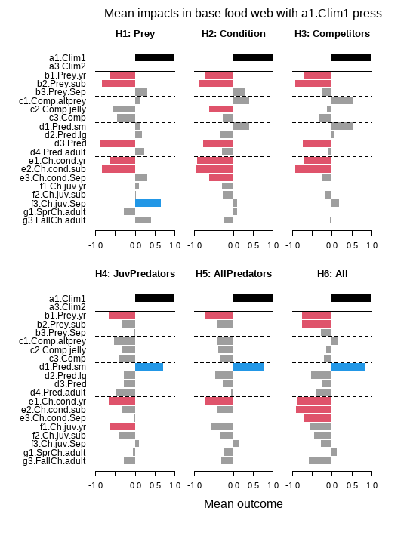**(a)**

***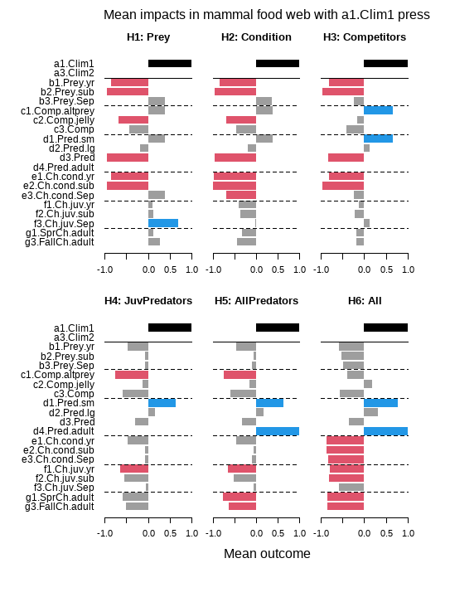*(b)**

## Figure S2.1 Outcomes of climate press on base and mammal networks for all nodes

Bar charts show the mean outcomes for each functional group in (a) the base and (b) the mammal network simulations after a climate perturbation, under each temperature hypothesis. The black bars represent the climate perturbation. Red bars indicate a consistently negative response, while blue bars indicate a consistently positive response. Gray bars represent either weakly signed or neutral responses (-0.6 to 0.6). The solid line highlights the climate perturbation that was applied, while dashed lines are for readability purposes. For descriptions of each hypothesis, refer to Figure 2.

# Supplement 3 Boosted regression tree results

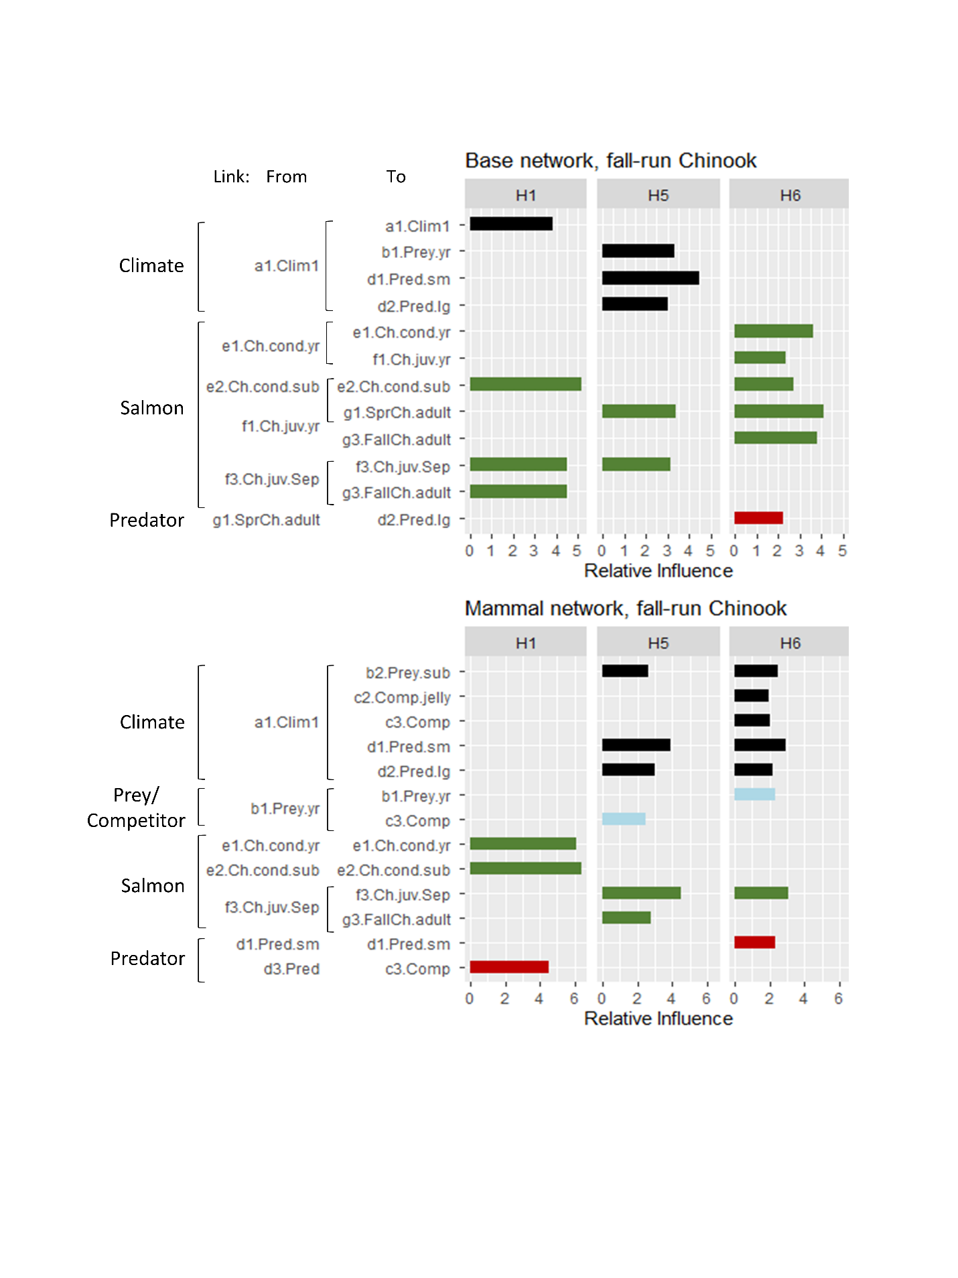

## Figure S3.1 Boosted regression tree influence plots for fall-run adult salmon outcomes

Each panel shows the relative importance of variables that made up the top 20% of cumulative importance for fall-run outcomes, based on a particular network configuration from the boosted regression tree analysis. The analysis assessed the influence of the weight assigned to specific links for predicting adult salmon outcomes (i.e., a positive or negative response to climate forcing). Base network results are shown in the top panel, while mammal network results are shown in the bottom panel. The first column shows the H1 scenario (bottom-up), the second column shows the H5 scenario (temperature-amplified predation), and the third column shows the H6 scenario (all groups directly affected by climate, see Figure 2). Links are grouped by type: climate drivers are shown in black, predators in red, competitors in pink, and salmon self-limitation, prey response, or life stage transitions in green. The y-axis names indicate the starting (From) and ending (To) nodes involved in the link, where ‘a’ represents a climate node, ‘b’ represents salmon prey, ‘c’ represents a competitor, ‘d’ represents a predator, ‘e’ represents salmon condition, ‘f’ represents juvenile salmon abundance, and ‘g’ represents adult salmon nodes (see Figure 1).

## Literature cited

Tucker, S., M. Hipfner, and M. Trudel. 2016. Size- and condition-dependent predation: A seabird disproportionately targets substandard individual juvenile salmon. Ecology 97(2):461-471. doi: 10.1890/15-0564.1.